LYA Summer Day Camp

Place: Lee Elementary School
Dates: June 21 – August 6, 2021
Time: 8:00 – 5:00
Open to children entering grades 1 – 7

LYA
“Where all youth are valued for their individuality”

Lee Youth Association summer day camp will focus on outside adventures this 2021 season. Our mission is to create a safe environment where children can play, grow, and learn. Exploring nature’s experience and building confidence along the way. Enjoying games and encouraging teamwork and friendships!

PLEASE NOTE:

The number of campers per day will be limited so please get your registrations in ASAP - once we have reached that limit, we will not be able to take any more registrations.

REGISTRATION FORM

Child’s Name

Address

Phone Number

DOB and Age

Grade (September 2021)

School

Allergies or other medical conditions _ Contact Information:
Parent/guardian Name (s)

Address

Phone (H) (W) (C)

Email Address

Additional Emergency Contact Info:

Name

Address

Phone (H) (W) (C)

Names of people other than parents/guardians who may pick up your child:
Name Phone Name Phone Name Phone

Please circle the days that your child will be attending (You may choose any days during that session – you do not have to go the full session – we divide into sessions for accounting purposes only).

Session 1

Week 1 – June 21, 22, 23, 24, 25

Week 2 – June 28, 29 30, July 1, 2

Week 3 – July 6, 7, 8, 9

Week 4 – July 12, 13, 14, 15, 16

Session 2

Week 5 – July 19, 20, 21, 22, 23

Week 6 – July 26, 27, 28, 29, 30

Week 7 – August 2, 3, 4, 5, 6

PLEASE READ CAREFULLY

The cost of the program is $23 per day (plus a $10 registration fee). The cost for a second child is $18 per day (plus a $10 registration fee). Payment is due for the first session at the time of registration in order to hold your slot. We will not accept registrations without payment in full for the first session. We accept credit cards, debit cards, PayPal, checks and cash.
Payment is due for the second session on July 9th. If you have not paid for your second session by July 9, we will automatically charge your credit card. We will include a form in your camper packet that you will need to complete giving us your credit card information.

We will have an early morning drop off program beginning at 6:30 A.M. – please contact the LYA with questions regarding this program - there is an additional charge of $5 for early drop off and you must register separately for this – however if you drop your child off prior to 8:00 and are not registered you will be charged the additional $5.

You are responsible for payment for all registered days regardless of whether your child attends or not.

IF YOU HAVE AN OUTSTANDING BALANCE WITH THE LYA FROM OTHER PROGRAMS YOU CANNOT ATTEND THIS PROGRAM UNLESS YOUR BALANCE IS PAID IN FULL – NO EXCEPTIONS!

Daily Schedule

6:30 – 8:00 – Early drop off
8:00 – 9:00 – Open gym & game area 9:00 – 11:45 – Scheduled activities
11:45 – 12:30 – Lunch in the cafeteria
12:30 – 4:15 – Scheduled activities
4:15 – 5:00 – Open gym & game area
5:00 – Program ends – parent pickup

Activities will include: arts, crafts, painting, kickball, volleyball, 4-square, basketball, baseball, dodgeball, cards, puzzles, board games, contests, nature walks, ice cream walks and much, much more!!!

Program Staff

All of our staff have experience working with children, some up to 20 years! Our staff this year are creative and energetic! We bring in interests from all corners of life. All staff are at a minimum First Aid and CPR certified up to our coordinator who is a certified EMT. They all love working with children and some have chosen that as their forever career!

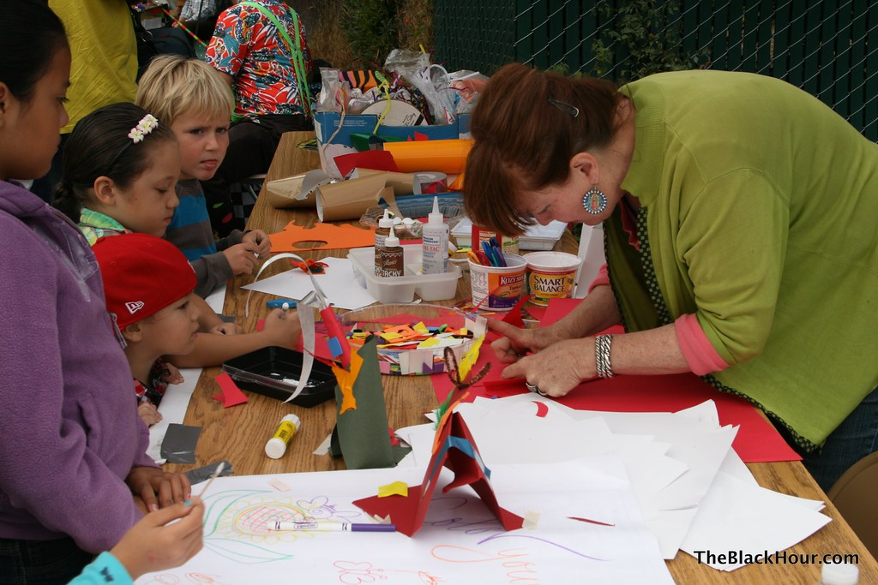

We are looking forward to a great summer!!!

